***Q1. Draw a flowchart to add two numbers entered by user***

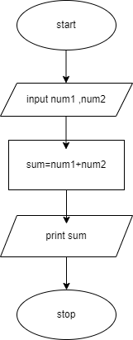

***Q2. Draw a flowchart that will read the two sides of a rectangle and calculate its area.***

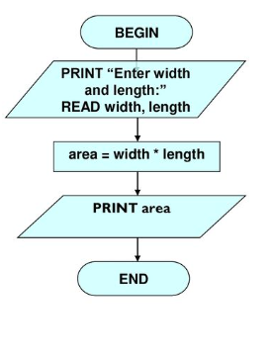

***Q3. A person can cast his/her vote if his/her age is 18 years or more than 18. Draw a flowchart to check whether a person can vote or not.***

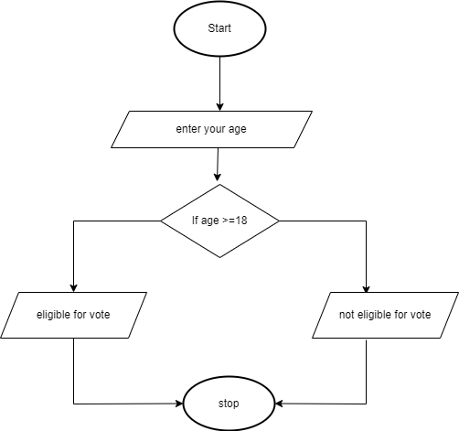

***Q4. Draw the flowchart to print the largest of any three numbers***

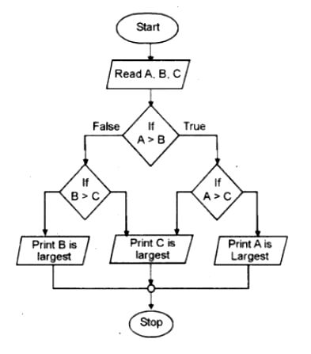

***Q5. Draw a flowchart that exchanges the value of two variables: x and y.  The output must be: the value of variable y will become the value of variable x, and vice versa.***

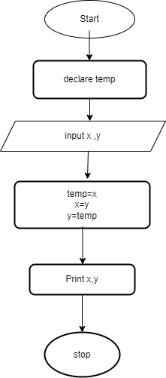

### Assessment Rubric for Lab

**Method for assessment:**

Lab reports and instructor observation during lab sessions. Outcome assessed:

a. Ability to conduct experiments, as well as to analyze and interpret data (P) b. Ability to function on multi-disciplinary teams (A)

c. Ability to use the techniques, skills, and modern engineering tools necessary for engineering practice (P)

|  |  |  |  |  |  |  |  |  |
| --- | --- | --- | --- | --- | --- | --- | --- | --- |
| **Performance metric** | **Task** | **CLO** | **Description** | **Max marks** | **Exceeds expectation** | **Meets expectation** | **Does not meet expectation** | **Obtained marks** |
| 1. Realization of experiment (a) | 1 | 1 | Functionality | 40 | Executes without errors excellent user prompts, good use of symbols, spacing in output. Through testing has been completed (35-40) | Executes without errors, user prompts are understandable, minimum use of symbols or spacing in output. Some testing has been completed (20-34) | Does not execute due to syntax errors, runtime errors, user prompts are misleading or non-existent. No testing has been completed (0-19) |  |
| 2. Teamwork (b) | 1 | 3 | Group Performance | 5 | Actively engages and cooperates with other group member(s) in effective manner (4-5) | Cooperates with other group member(s) in a reasonable manner but conduct can be improved (2-3) | Distracts or discourages other group members from conducting the experiment (0-1) |  |
| 3. Conducting experiment (a, c) | 1 | 1 | On Spot Changes | 10 | Able to make changes (8-10) | Partially able to make changes (5-7) | Unable to make changes (0-4) |  |
| 1 | 1 | Viva | 10 | Answered all questions (8-10) | Few incorrect answers (5-7) | Unable to answer all questions (0-4) |  |
| 4. Laboratory safety and disciplinary rules (a) | 1 | 3 | Code commenting | 5 | Comments are added and does help the reader to understand the code (4-5) | Comments are added and does not help the reader to understand the code (2-3) | Comments are not added (0-1) |  |
| 5. Data collection (c) | 1 | 3 | Code Structure | 5 | Excellent use of white space, creatively organized work, excellent use of variables and constants, correct identifiers for constants, No line-wrap (4-5) | Includes name, and assignment, white space makes the program fairly easy to read. Title, organized work, good use of variables (2-3) | Poor use of white space (indentation, blank lines) making code hard to read, disorganized and messy (0-1) |  |
| 6. Data analysis (a, c) | 1 | 4 | Algorithm | 20 | Solution is efficient, easy to understand, and maintain (15-20) | A logical solution that is easy to follow but it is not the most efficient (6-14) | A difficult and inefficient solution (0-5) |  |
| 7. Computer use (c) | 1 | 2 | Documentation & Github Submissions | 5 | Timely (4-5) | Late (2-3) | Not done (0-1) |  |
|  | Max Marks (total): | | | 100 | Obtained Marks (total): | | |  |

Lab Engineer Signature: ________________________